**Bayonet Mounting w/ Connectors**

The bayonet mount offers an easy to attach/remove mechanism which ensure proper alignment of connectors.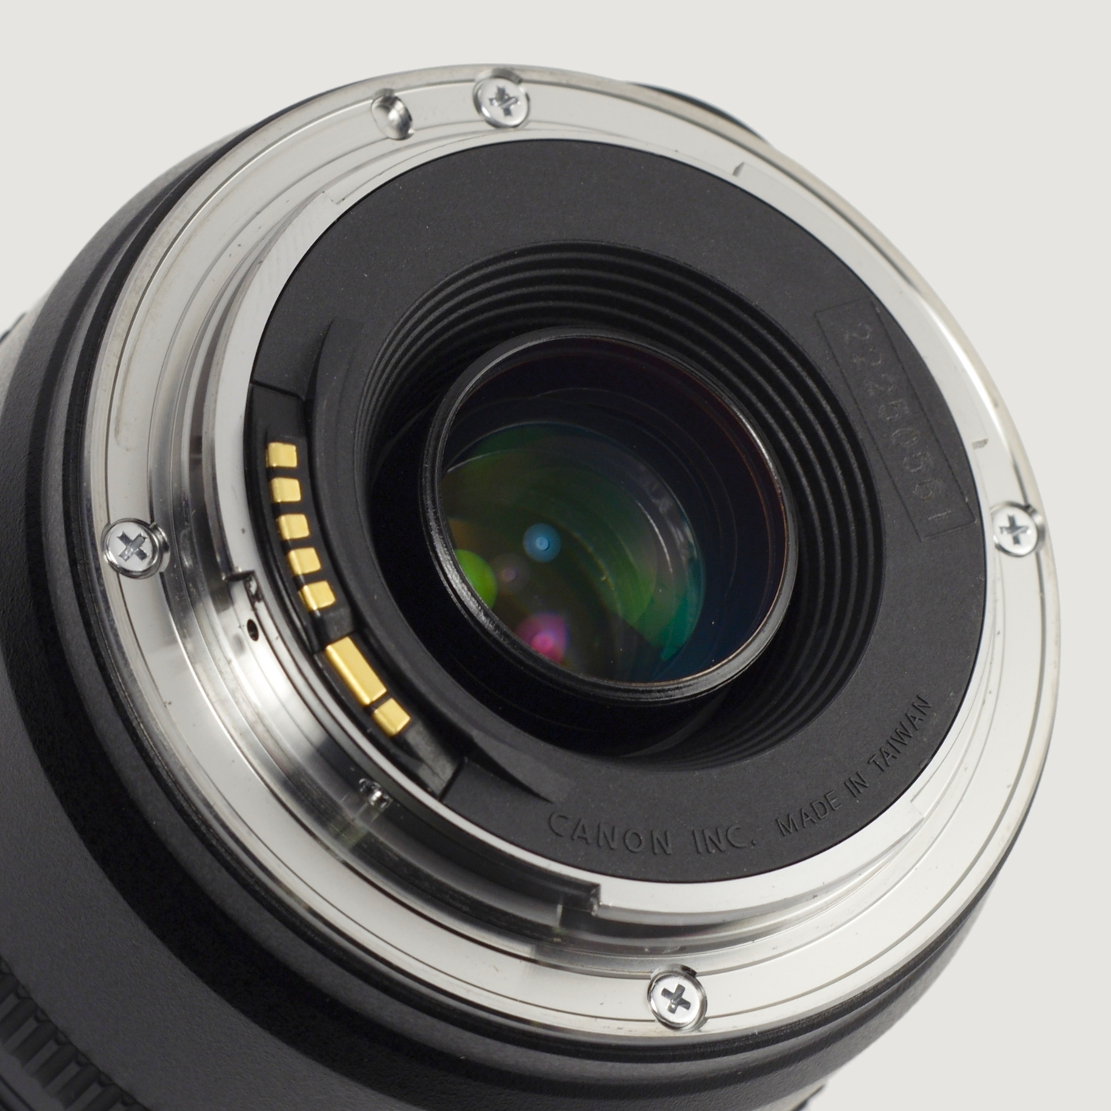

Example of connector pin layout

[Canon EF mount pins](http://www.ask.com/wiki/Canon_EF_lens_mount?o=2801&qsrc=999&ad=doubleDown&an=apn&ap=ask.com)

The communication protocol between the camera is 8-data-bit, 1-stop-bit [SPI](http://www.ask.com/wiki/Serial_Peripheral_Interface_Bus?qsrc=3044) (mode 3). The pins, from right to left on the lens, are:

|  |  |
| --- | --- |
| Name | Function |
| VBat | +6 [volts](http://www.ask.com/wiki/Volt?qsrc=3044) to power internal lens focus motors |
| P-Gnd | Power ground |
| P-Gnd |
| VDD | +5.5 [volts](http://www.ask.com/wiki/Volt?qsrc=3044) Digital logic power |
| DCL | Data from camera to the lens (MOSI) |
| DLC | Data from the lens to the camera (MISO) |
| LCLK | Camera body generated clock signal (SCLK, CPOL=1) |
| D-GND | Digital logic ground |
| COM1 | [Teleconverter](http://www.ask.com/wiki/Teleconverter?qsrc=3044) common[[25]](http://www.ask.com/wiki/Canon_EF_lens_mount?o=2801&qsrc=999&ad=doubleDown&an=apn&ap=ask.com#cite_note-x1.4-25)[[26]](http://www.ask.com/wiki/Canon_EF_lens_mount?o=2801&qsrc=999&ad=doubleDown&an=apn&ap=ask.com#cite_note-x2-26)[[27]](http://www.ask.com/wiki/Canon_EF_lens_mount?o=2801&qsrc=999&ad=doubleDown&an=apn&ap=ask.com#cite_note-LSC-27) |
| EXT0 | Short to COM1 for 'Life Size Converter' and x1.4 teleconverter |
| EXT1 | Short to COM1 for x2 and x1.4 teleconverter |

**WiFi SD Card**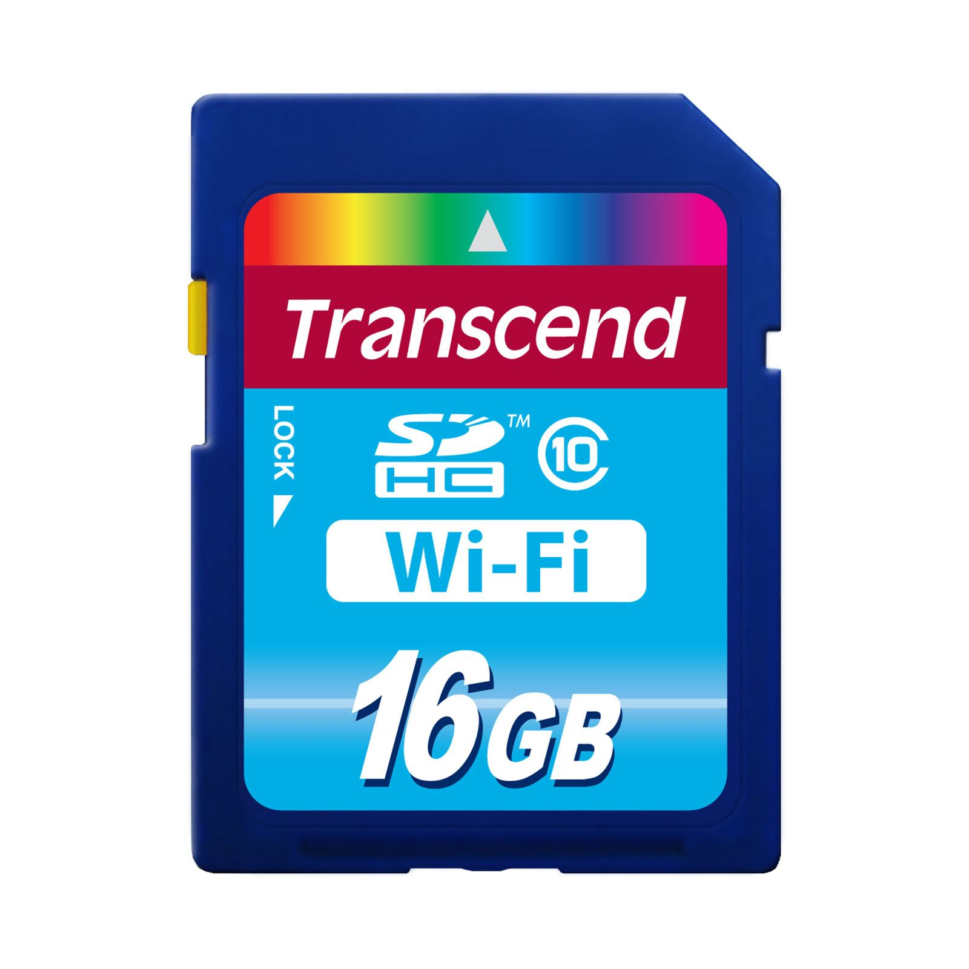

Contains “Radio-on-a-Chip for Mobile” (ROCm) for wireless access point with external storage, ranging from 2~32GBs, for software or data storage.

**Battery**

Provides power to the main and connected device

**Features:**

* Devices powers connected external devices
* External devices should have ON/OFF switch
* Transmits and receives data on behalf of external device
* Slot case must be externally accessible for easy of switch-out in case component is damaged
* Devices must be easy to insert and eject from slot case
* Device must be rechargable without removal of battery
* Female bayonet plate must be woven into spacesuit and front plate must be exposed for easy attachment